**P6 & M2**

**Introduction**

In this assignment, I will describe the different transmission methods used and I will explain the particular transmission methods that are chosen in particular situations. For P6, I will explain the following:

* ***Transmission****:* methods eg coaxial, optical fibre, unshielded twisted pair (UTP), shielded twisted pair (STP), infrared, radio, microwave, satellite.
* ***Electronic communication*:** methods eg simplex, duplex, half-duplex communication, parallel, universal, serial bus, serial, infra-red, Bluetooth, WiFi, 3G

**Transmission**

**Fibre Optic**

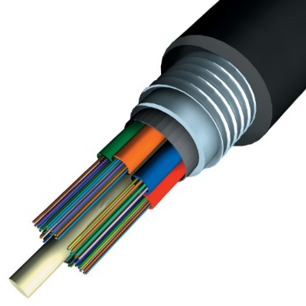A fibre optic cable contains dozens of strands. Approximately, each strand is as thin as one human hair. If it were that thin, it would take time to cable. Therefore, the disadvantage is that it would need professional person to insert these strands and cable it in. However, the advantage is that it transmits data through light rather than electricity. Referring to Figure 1.1, it shows how a fibre optic cable looks like. These high-intensity light beams are generated by lasers and are conducted along the transparent fibres. Inside the fibre-optic cable, an insulating glass cladding and a protective coating surround each optical fibre. Because it transmits via light rather than electricity, fibre-optic cable has several advantages over cables that uses wire. If it were that thin, it would take time to cable. Therefore, the disadvantage is that it would need professional person to insert these strands and cable it in. However, the advantage is that it transmits data through light rather than electricity. They are many reasons why organisations use fibre optic, as it is cheap for organisations. Many users would want the cable to come in cheap and work fine. Another reason is that it is thin. It might be risky but it is easy to handle to fix.

Figure 1.1

**Coaxial Cable**

Coaxial cable is different from the others of its appearance. It is a type of cable that is surrounded by a protected layer. It is like a shield for it to be protected.

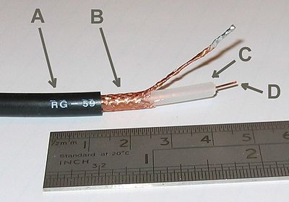The image shows how many layers it is to be protected. A is the outside plastic layer, B is the copper layer, C is the white insulator and D is the copper core. The advantage for using this coaxial cable is that it reduces any errors that any other cable can come across e.g. noise. Noise is a big problem for anyone as it can cause a loss of concentration for any person. This is why this particular cable is used for organisation so it can prevent any noises for the students to concentrate. However, the disadvantage is that it has many layers; it would be difficult to work with. If they were any errors within the cable, it would be difficult to fix. In addition, another disadvantage is that it is expensive.

**Shielded Twisted Pair (STP)**

**Shielded twisted pair** cabling has a protective layer rapped around the cables to prevent it from making noises. In addition, shielded twisted pair cabling can carry data at a faster speed. However, it is expensive and it is more difficult to work with. This is why this particular transmission is used for particular situations because it can carry data fast. For example, if an organisation were to send an important email to another person, they would receive it straight away with this cable. This cable enables data to be carried faster for people. It is a pair and it enables data to be carried faster. This is why it can be carried because of the pair. They work together. It is electronically cleaner. It is important for it to be electronically clean as if it were to be dirty; it can cause many problems that can cause other problems. However, the disadvantage for STP is that it is expensive hence the fast data travelling. As it is much larger, it is more difficult to set up on a terminating block.

**Electronic Communication**

**Infra-red (IrDA)**

**Infrared Data Association** could be referred to as IrDA. IrDA is an industry provides specification for a set of protocols for wireless infrared communications. This organisation was founded in 1993. The main reason for using IrDA is that it can extend the data transfer for another last meter. It is implemented in mobile phones and other devices that the internet is used e.g. laptops and cameras.

**Bluetooth**

Bluetooth uses the same principles as 3G and Wi-Fi. Depending on the device that the user is using, you will find that Bluetooth vary. It can be used for PAN (Personal Area Network. They are three different types of Bluetooth:

* Bluetooth can communicate over a distance of 100 metres
* Bluetooth used on mobile phones, 10 metres
* Bluetooth used hands-free, 1 metre

All these devices use Bluetooth; only the distance that differs.

**3G**

3G is implemented into mobile phones so that they can be used wirelessly without using Wi-Fi. It depends on the provider – O2, Vodafone or T-Mobile – whether the connection has a good strength or not. The newest mobile technology is 4G. It transmits data faster depending on the provider. The location could affect the signal. If you are in a school, where normally signal is weak, the data transmitted would be slow/or would not work.



**Table**

|  |  |  |
| --- | --- | --- |
|  | Wireless | Wired |
| ADVANATAGES | * No use of cable * It can transmit data wirelessly * The user does not need to worry about any wires. If any wires goes wrong for the ‘wired network’, the user needs to fix it, but in this case, he does not need to fix it, as they are no wires. | * Easy to set up than wireless connection * Expensive than wireless * Better transmitting any data than wireless. It goes through cables, which is faster than wireless. Wireless network the user has to wait as there is signals involved. |
| DISADVANTAGES | * People can easily access the network once they get the password. If the network is secured with an easy password e.g. 12345, people can guess that easily and use the network * Router has the network password on there. If the user does not change it, they have a risk of getting an unauthorised user within the network * Router can get damaged as this network is wireless | * It is not portable. Therefore, the user has to use the network in one place * Large data that is used will slow the network down |

**Conclusion**

Throughout these criteria’s, I have learnt a lot of information regarding cabling. It gives an insight of what an organisation needs to look for before getting any cable. For example, each cable is different. If they want to use a cheap one, they can choose fibre optic. This relates to real life especially for organisations. They deal with heavy amount of data and they need it to be sent either fast or last long, a bit of advice for any potential entrepreneur, they need to check what they need specifically.

To relate it to ‘real life’, coaxial cable is made out of copper. This is very hard to get and many employees have to dig into the ground to get copper. One problem is that no one should waste using copper. It is important to remind ourselves how we get copper. People have to work hard to dig only a small amount for it. They do not dig in the big cities, but in the deprived countries where they have to dig copper to earn money.

Fibre optic and coaxial are two different cables as mentioned above. They are two different, but personally, I like to use coaxial due to its protection and prevention from noise. Others have their own opinion, but I think that coaxial is better.

**Reference**

<http://en.wikipedia.org/wiki/Coaxial_cable>

<http://sandrav3110.blogspot.co.uk/2009/09/advantages-and-disadvantages-coaxial.html>

**P1 – Unit 2**

**P3 – Unit 9**

**BTEC LEVEL 3 BOOK**